- The invited participant will receive the invitation by email.
- Open the email and click on “Open Microsoft Teams”.

- Click on Send code to receive the One Time Password to join the Team.
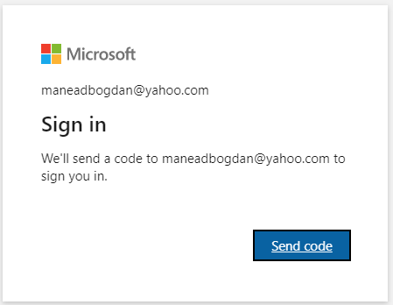
- A second email containing the One Time Password (OTP) will be received.
- Open the email which contains the verification code to Join EUMM Team. The code is 8-digit number, as shown below.
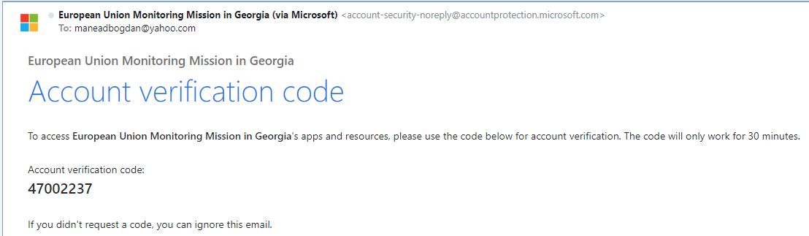
- The invited person must Accept the agreement to continue the joining process.
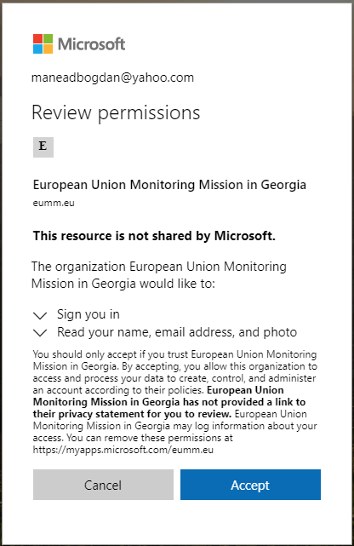
- Wait a few moments until the process is finalized and access is granted.
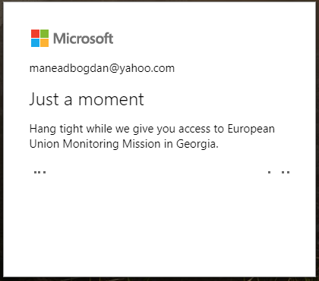
- After the process is completed, the participant will be presented two options, either to “Download the Windows app” or “Use the web app instead”. You may choose to use the browser directly, or to download and install the app in Windows (installation does not require Administrative permissions)
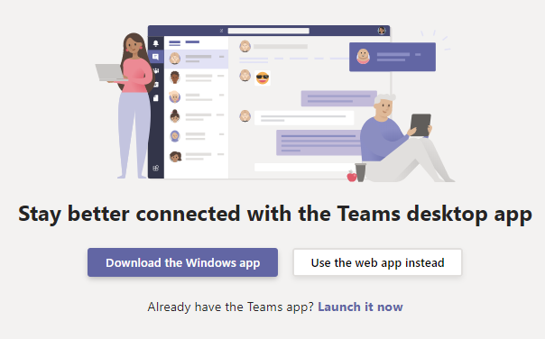
- Once you access Microsoft Teams interface, you can adjust Video / Audio Settings by click on Account Icon (top-right corner), Settings / Devices. In order to verify the quality and sound levels, you may perform a Test Call with the network.
